Introduction to Recommender Systems (Fall 2026)
Homework #1 (Due: Oct 18)

Student ID
Name
GitHub Repository

Instruction: You should submit your code and report to the i-campus. Follow the submission format below.
- RS_HW1_{STUDUENT_ID}_{NAME}.pdf
(This document in PDF format, including your GitHub repository for this HW)

NOTE 1: Please install the RecBole library.
https://github.com/RUCAIBox/RecBole

Ex1) pip install recbole

Ex2) git clone https://github.com/RUCAIBox/RecBole.git && cd RecBole
pip install -e . --verbose

NOTE 2: Please follow the instruction on https://github.com/RUCAIBox/RecBole
Read https://github.com/RUCAIBox/RecBole/blob/master/recbole/quick_start/quick_start.py

Ex1)
from recbole.quick_start import run_recbole
run_recbole(
model='ItemKNN',
dataset='ml-100k'
)

Ex2)
python run_recbole.py --model=[model_name] --dataset=[dataset_name]

(1) Neighborhood-based CF (KNN)
Execute two representative neighborbood-based models, such as ItemKNN and UserKNN.
- https://github.com/RUCAIBox/RecBole/blob/master/recbole/model/general_recommender/itemknn.py
Use the “ml-100k” dataset, which comes preloaded with RecBole.
Example code:
*python run_recbole.py --dataset=ml-100k --model=ItemKNN --k={k}
*python run_recbole.py --dataset=ml-100k --model=ItemKNN --k={k} --method=user

[Q] Run the above code using different values of k. Observe how the model performs under these conditions. Draw the plots of evaluation metrics by adjusting k (i.e., the number of nearest neighbors) for ItemKNN and UserKNN, respectively. (i) For varying k, explain the results and how much k affects the metrics. ii) Evaluate which of the two algorithms, item-based and user-based collaborative filtering, is better?
- Search space of k = {1, 5, 10, 100, 500}
Note: Show your plots and explanations in short (3-5) lines.
Answer:

(2) Latent Factor Model (BPR)
Execute a representative model, such as BPR. Use the “ml-100k” dataset, which comes preloaded with RecBole.
- https://github.com/RUCAIBox/RecBole/blob/master/recbole/model/general_recommender/bpr.py

[Q] Draw the plots of NDCG by i) adjusting the embedding size of BPR, ii) adjusting the regularization term,
- reg_lambda: 0.1, embedding_size: {32, 64, 128, 256}
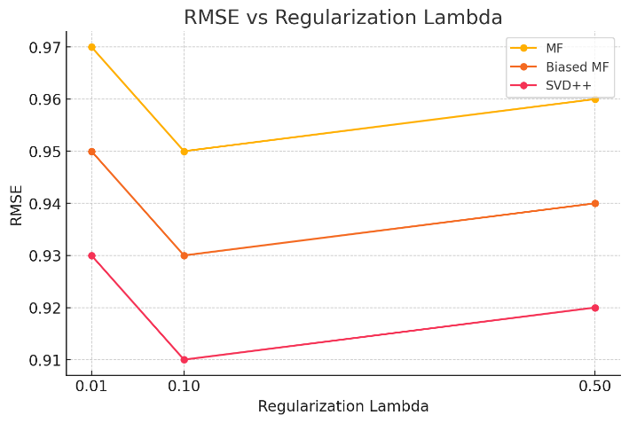
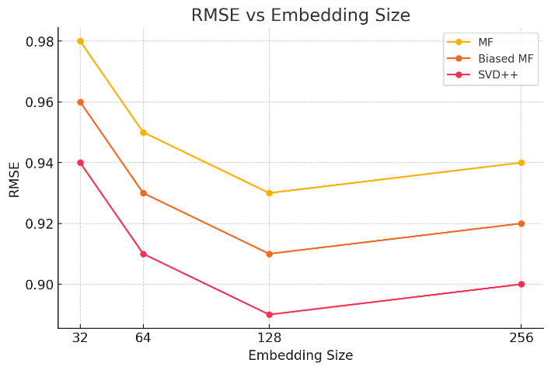
- embedding_size: 64, reg_lambda: {0.01, 0.1, 0.5}
Please refer to the example plots with a dummy value.
Note: Present your plots and explanations in brief (3-5 lines).
Answer:

(3) Item-to-item CF (SLIM, EASE)
Execute representative item-to-item models, such as SLIM, EASE. Use the “ml-100k” dataset.
- https://github.com/RUCAIBox/RecBole/blob/master/recbole/model/general_recommender/slimelastic.py
- https://github.com/RUCAIBox/RecBole/blob/master/recbole/model/general_recommender/ease.py

[Q] Report the performance of SLIM and EASE, and compare them with ItemKNN. Which is better? and why?
Answer:

